SHROPSHIRE JUNIOR FOOTBALL LEAGUE


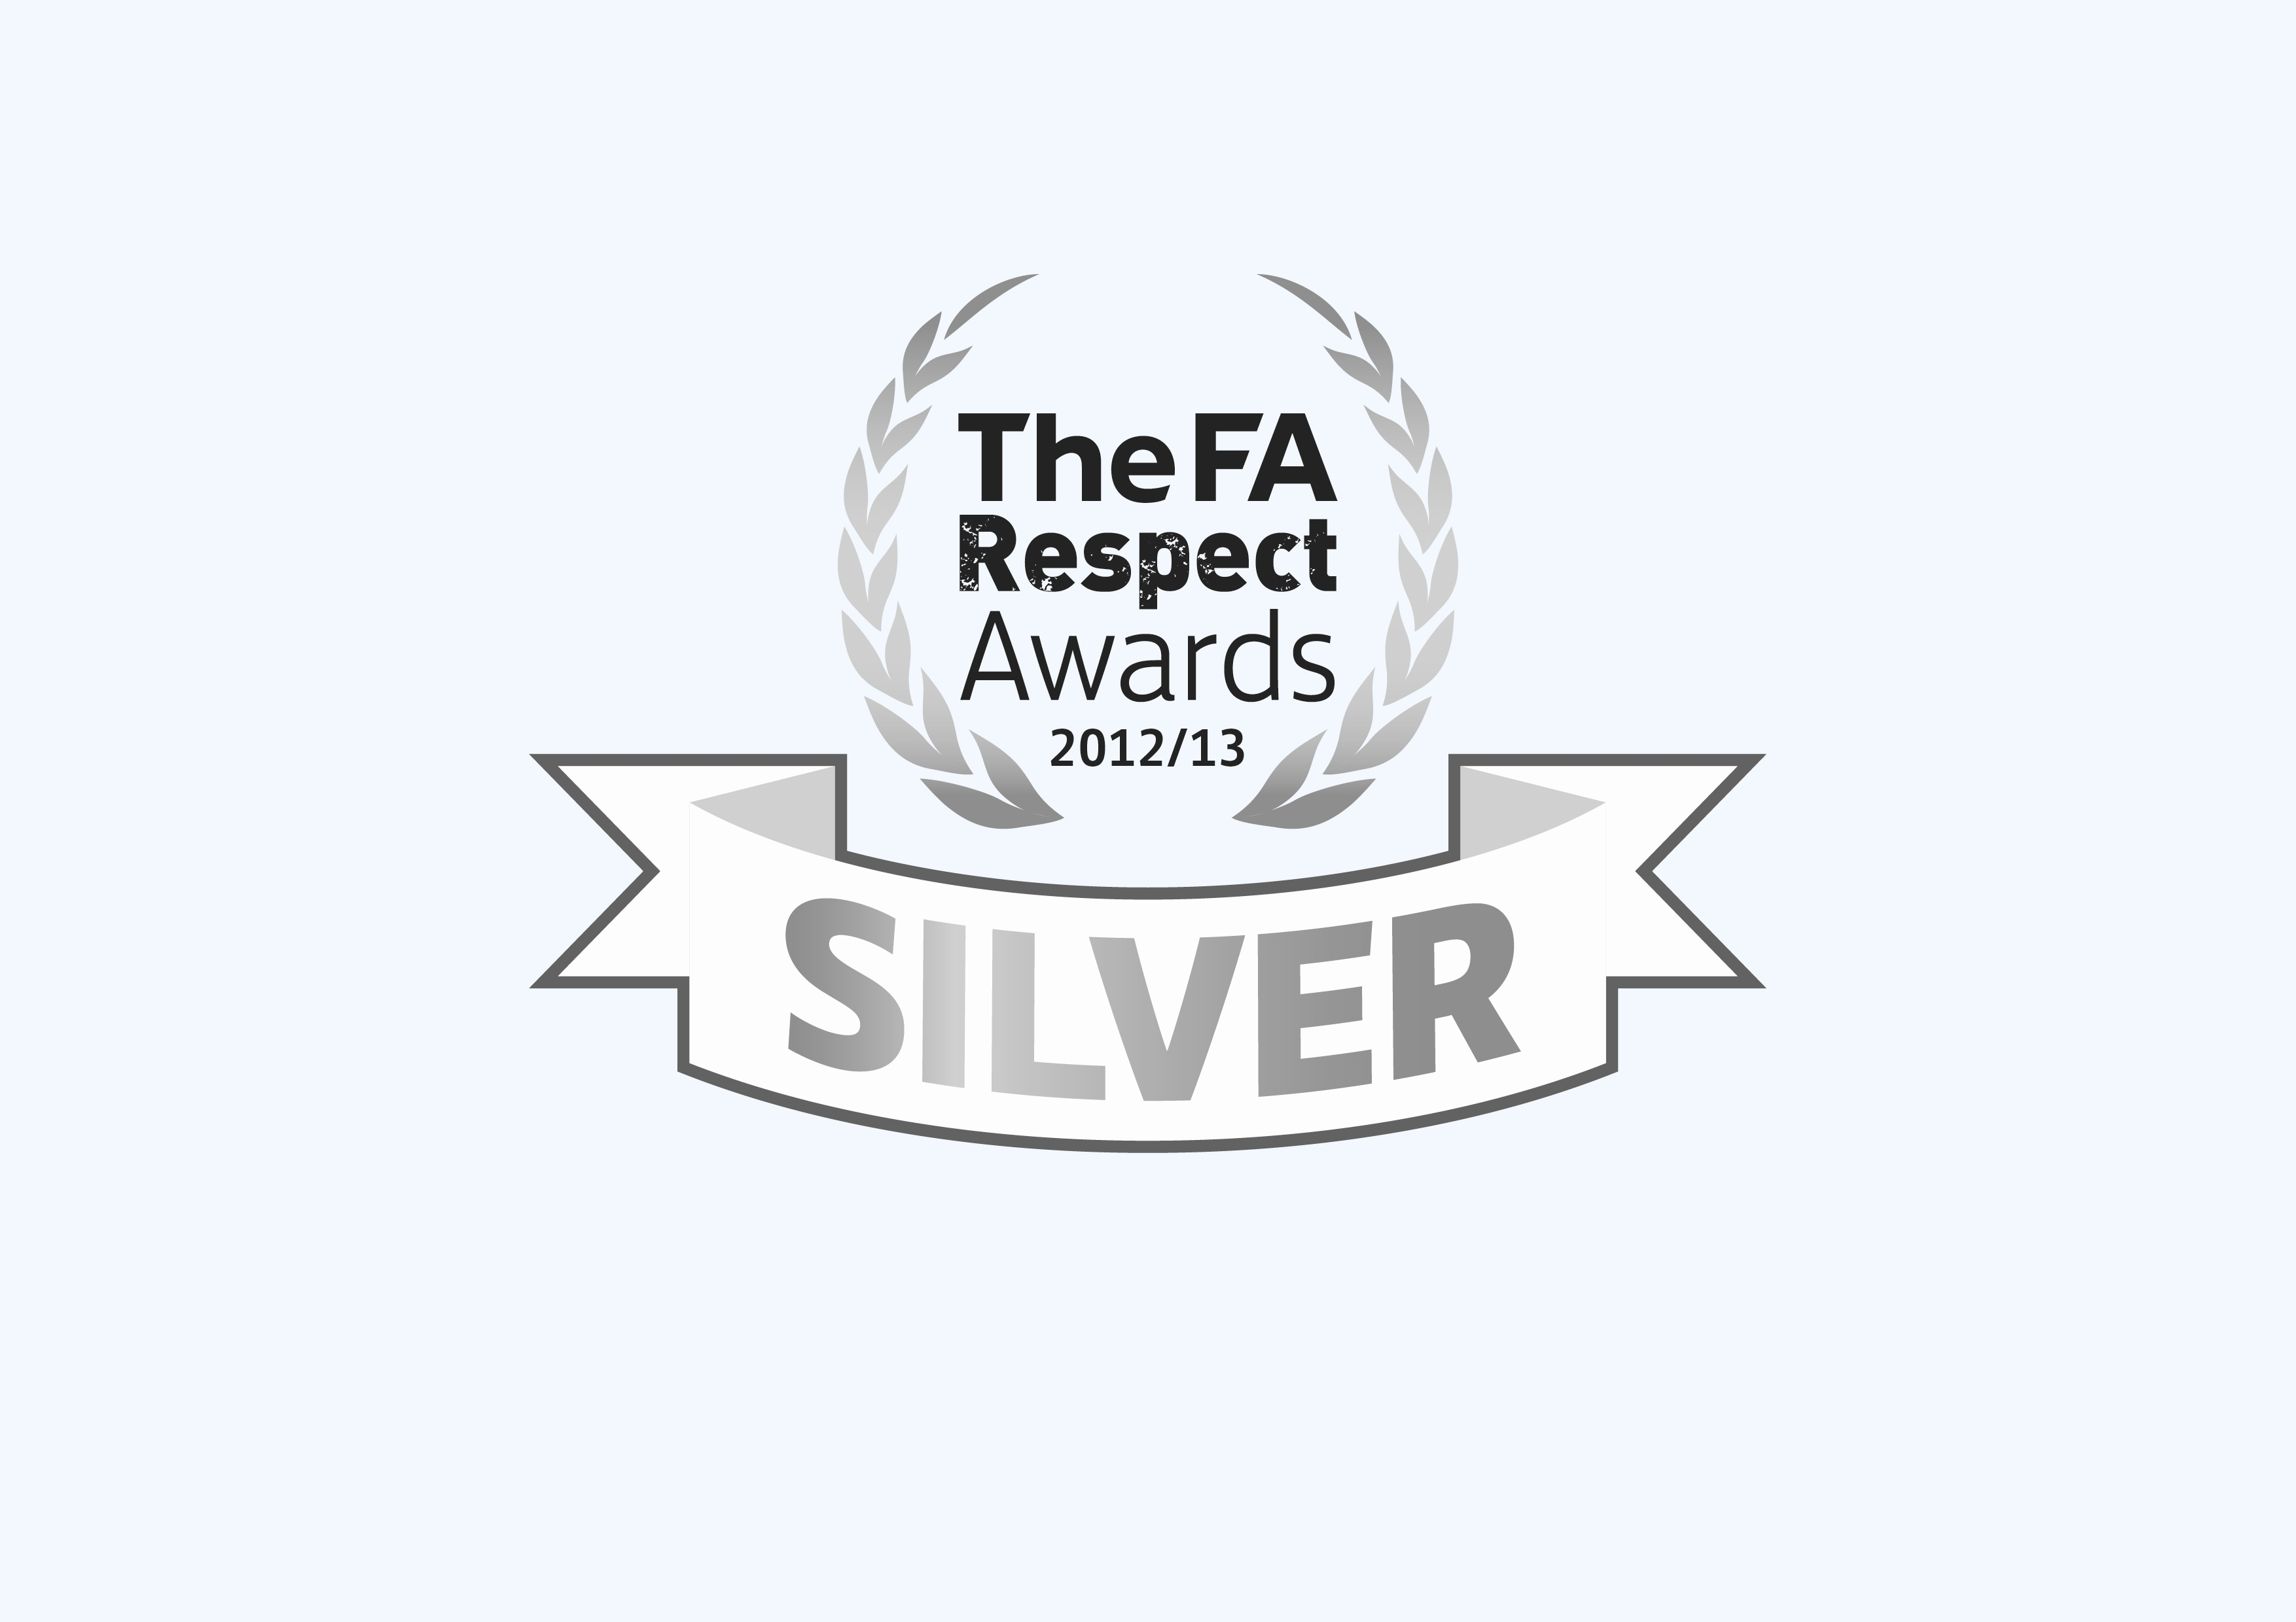
RESPECT & FAIRPLAY AWARD FORM (mini-soccer) - SEASON 2013-14
SPONSORED BY TURNER PEACHEY CHARTERED ACCOUNTANTS

1. Details Of Team Completing The Respect Form

Club &Team (name): ........…………………………….................... (Home or Away Team)

Manager & Assistant’s names:.......................……………………………………...

Date of Fixture:..................................................age group & div: U....….......…

Opposition (club & Team Name)...................................................................................

Competition (League/cup/charity cup etc):…..…....................……………….........……

2. RESPECT Based Playing Environment and Set-Up
Please delete as appropriate. Were RESPECT criteria in place or not at the match venue

Designated Spectator Area (barriers/coned/roped/marked) YES / NO

Coaches positioned on opposite side of pitch to parents YES / NO

Was the team supervised by the named officials as per handbook YES / NO

Were technical areas coned off for coaches and players YES / NO

Was the RESPECT handshake implemented before kick-off YES / NO

Was RESPECT promotional material displayed at the venue YES / NO

3. Opposition Team Fair Play, Respect and Conduct
Please indicate marks out 100 for the conduct and fair-play of opposing players,
100: Excellent attitude & conduct

80: Very good attitude & conduct

60: Above average attitude & conduct

50. Average attitude & conduct

30: Poor attitude & conduct

10: Inappropriate attitude & conduct
managers, coaches and spectators

Opposition Players

enter
marks
enter
marks

Opposition Mangers/Coaches

Opposition Spectators

enter
marks

4. Referee
Please indicate the name of the referee who officiated the game and a mark out of 100 for their
performance. Marks should be based on official’s control of the game & application of the laws.

Referees Name ………………………………………… Mark (out of 100)......…….
(Any marks of 30 or below must be accompanied by a written report on the back of this form)
was the referee qualified/registered with Shropshire FA................ YES/NO

Any marks of 30 or below given for referee and/or opposition’s fair play, code of conduct/respect must be accompanied by a written report on this form and set out as below. Report must include reasons for giving marks as per Rule 11(H) & only be appropriate to the issue(s) raised.

Please note this report will be used by ‘The League’ for fair-play/respect appraisal information purposes only and not for instigating (*) any disciplinary matters.

(*) Separate written notification must be lodged for issues of a formal protest or complaint and be received by the league secretary within seven days of the match or occurrence to which they refer as per rules 15(b) &15 (d)
Team (appropriate to the issue(s) raised):

Team

MANAGER (appropriate to the issue(s) raised):

Supporters (appropriate to the issue(s) raised):

Referee ( appropriate to the issue(s) raised).

Signed…………………………………………… Date…………………………….

